Assignment Questions

* Write a shell script that consists of a function that displays the number of files in the present working directory. Name this function “file_count” and call it in your script. If you use variable in your function, remember to make it a local variable.

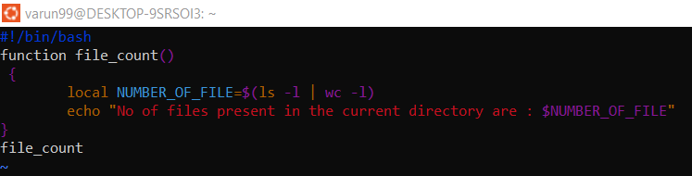

* For each directory in the $PATH, display the number of executable in that directory

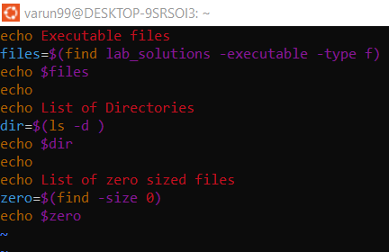

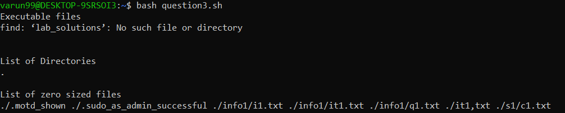

* Write a script that takes any number of directories as command-line arguments and then lists the contents of each of these directories.

